S3 File Upload and Integrity Validation Using SHA-256 Checksum

Contents
1. Objective : 2
2. Checksum 2
Checksum = the proof that the file was not changed. 2
It verifies: 2
2.1 HOW checksum integrity check works (concept) 2
Step A — Calculate checksum on your local file 2
Step B — Get checksum from S3 2
3. Configure AWS using credentials via cli. 3
4. Create a new test file 3
5. Compute local checksum (original file) 4
6. Upload the file to AWS S3 4
7. Download the same file back 4
8. Compute the Checksum of download file 4
9. Compare both checkums 5
10. Conclusion 6

Complete step-by-step documentation

Objective :
- Upload a file from a local machine to an Amazon S3 bucket
- Validate the data integrity of the uploaded file
- Understand checksum (SHA-256) and how it is used to detect corruption
- Confirm that the file uploaded to S3 matches the original file exactly
This is a critical cloud engineering skill used in backups, migrations, and secure data transfer.

Checksum

Checksum = the proof that the file was not changed.

It verifies:
- No corruption
- No modification
- No partial upload
- No network error
- No tampering

2.1 HOW checksum integrity check works (concept)

Step A — Calculate checksum on your local file
You run:
CertUtil -hashfile myfile.txt SHA256
Local checksum might be:
AAA111BBB222CCC333...

Step B — Get checksum from S3
Two ways:

1. If S3 stores checksum metadata
(using head-object):
ChecksumSHA256 = "AAA111BBB222CCC333..."
If the checksums match → integrity = OK.

2. If S3 does NOT store checksum (like your case)
Then do this:
Download the file:
aws s3 cp s3://bucket/myfile.txt downloaded.txt
Calculate checksum of downloaded file:
CertUtil -hashfile downloaded.txt SHA256
Compare:
Local: AAA111BBB222CCC333
Downloaded: AAA111BBB222CCC333
If they match → file is exactly identical.

Configure AWS using credentials via cli.
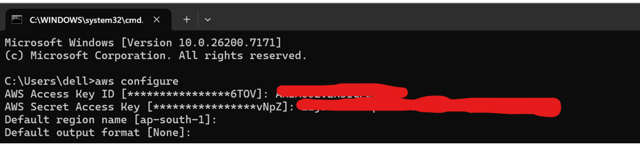

Create a new test file
run this command: echo this is a new test file > testfile.txt
verify it exists: >>>> dir testfile.txt
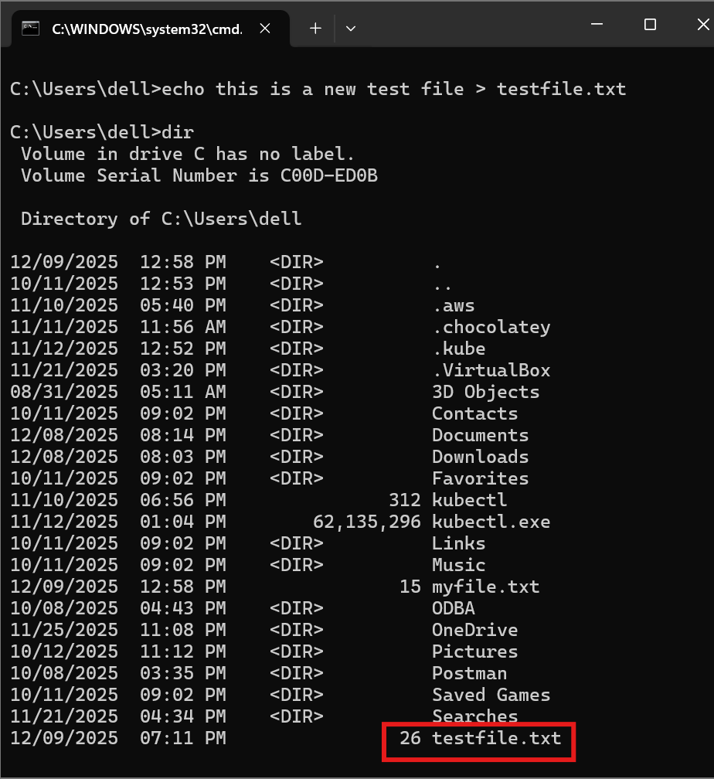

Compute local checksum (original file)
Run : CertUtil -hashfile testfile.txt SHA256
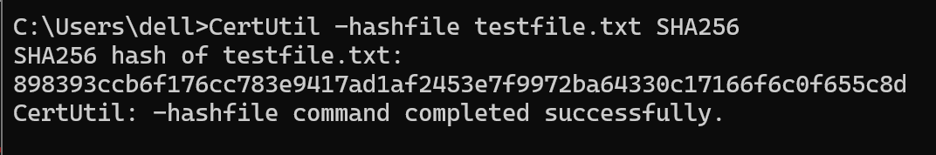
This is the digital fingerprint of your file.

Upload the file to AWS S3
Run : aws s3 cp testfile.txt s3://preeti-demo-bucket-2025-12-09/
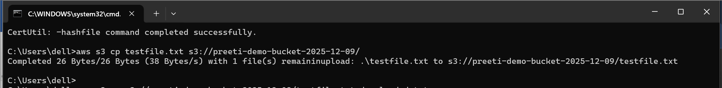
you should see:
upload: ./testfile.txt to s3://preeti-demo-bucket-2025-12-09/testfile.txt
This means the upload succeeded.

Download the same file back
Run : aws s3 cp s3://preeti-demo-bucket-2025-12-09/testfile.txt downloaded.txt
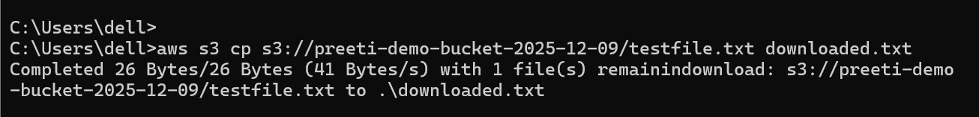
Now you have a second copy called downloaded.txt, which came from S3.

Compute the Checksum of download file
Run : CertUtil -hashfile downloaded.txt SHA256
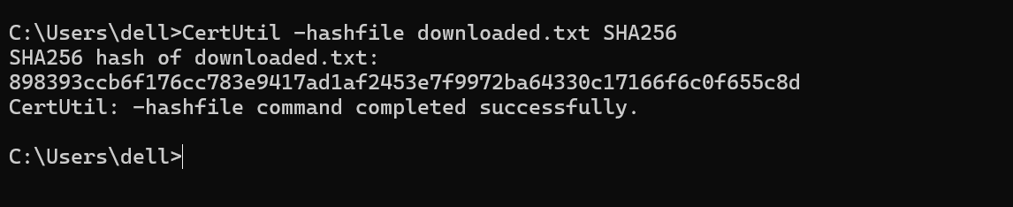
You will get another long hash string.

Compare both checkums
If both checksums are IDENTICAL: Your original file == Your S3 file
That means:
Integrity preserved
No corruption
No changes.

If they are DIFFERENT:
Something changed during upload/download.
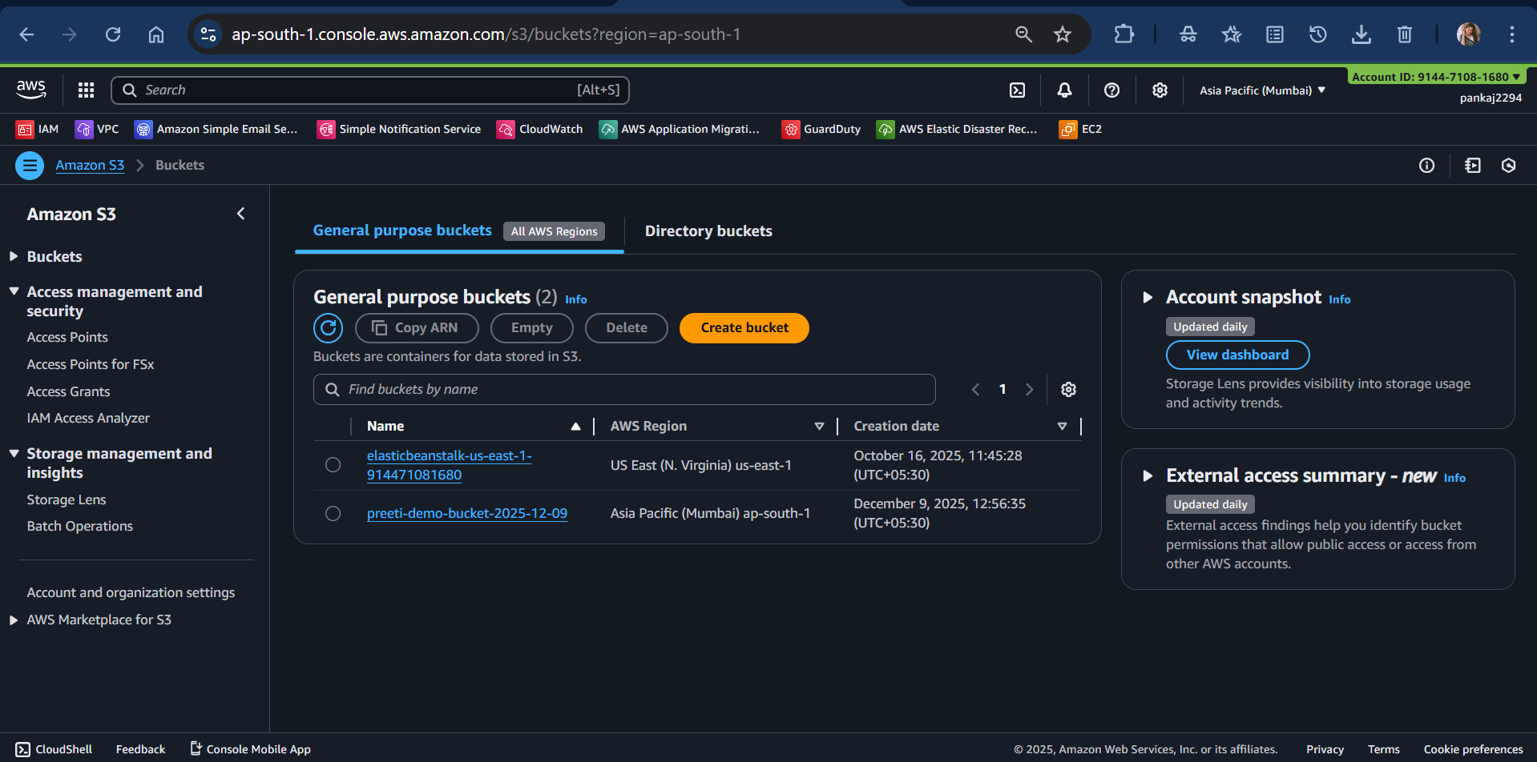
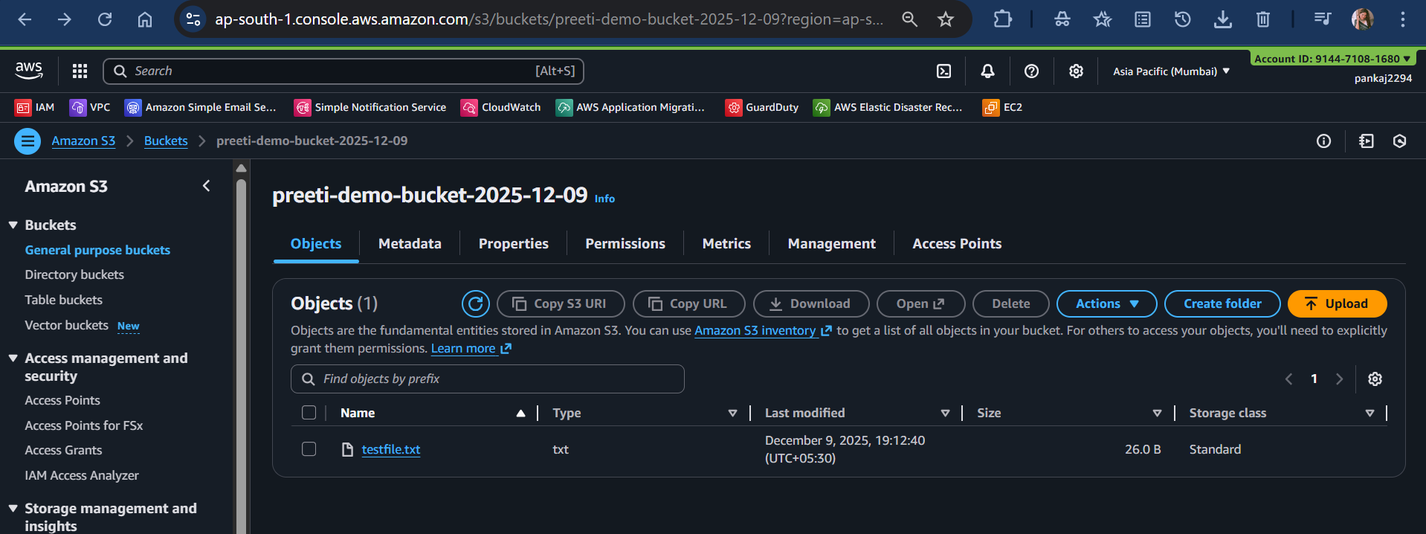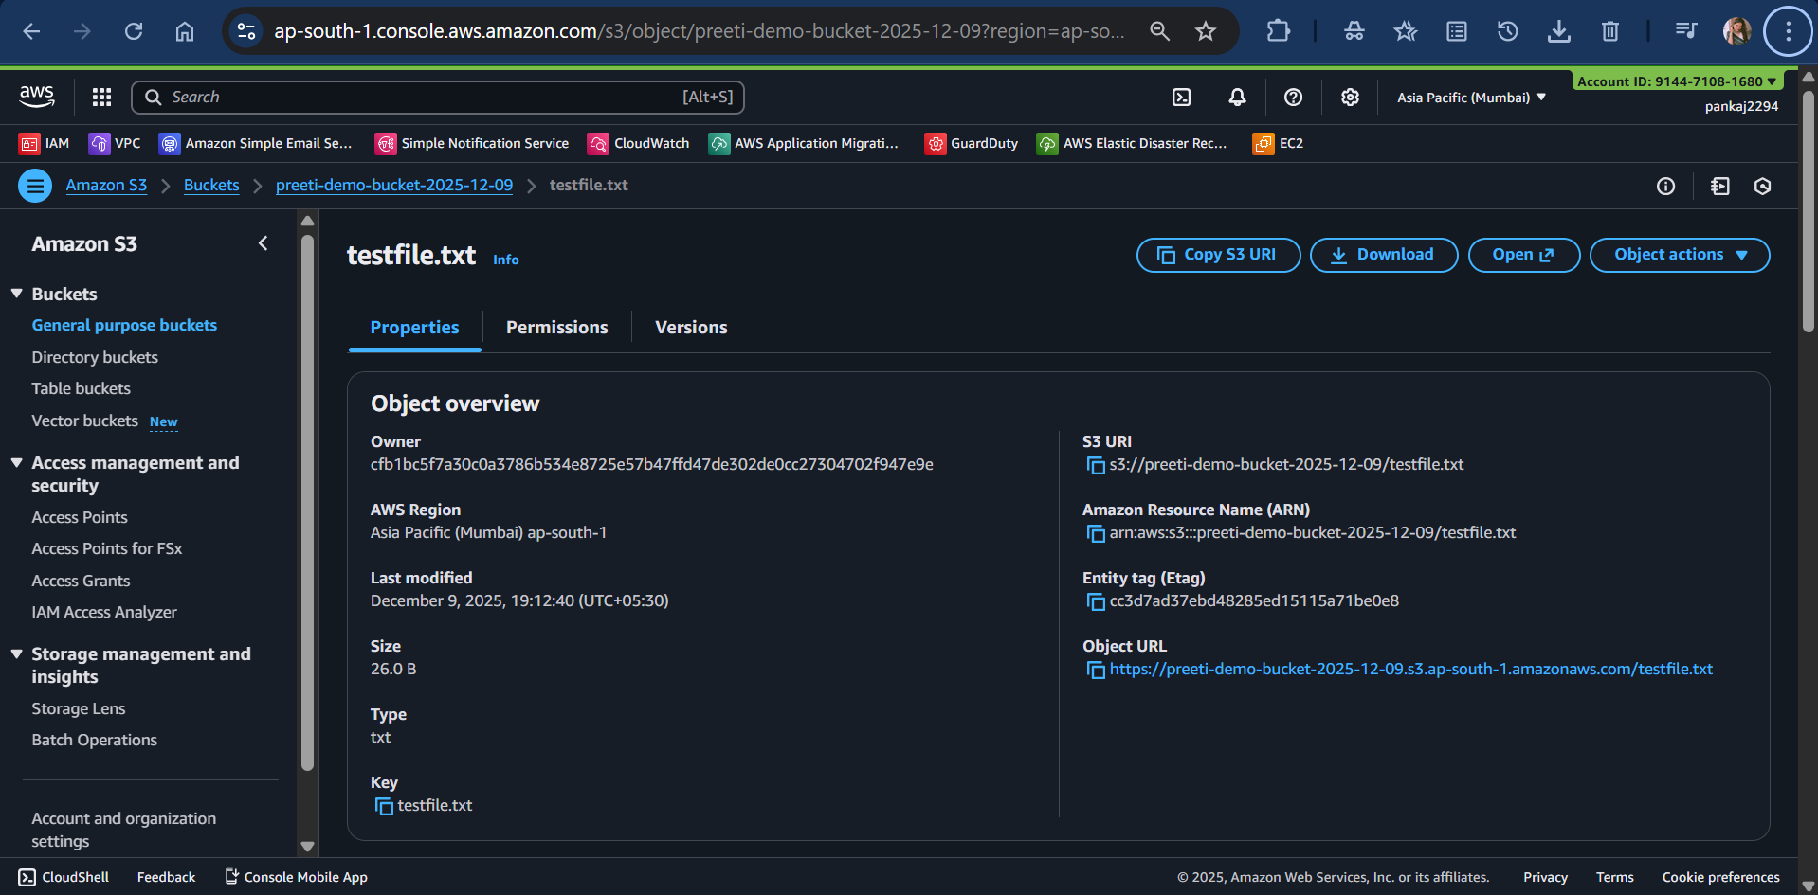

Conclusion
A checksum is a digital fingerprint of a file
SHA-256 produces a unique hash.

Uploading to S3 did not modify or corrupt the file
The fingerprints were identical.

This proves the file was transferred correctly
No corruption
No loss
No extra bytes
No changes

You manually performed a data integrity validation workflow
This is exactly what cloud engineers do for:
backups
database dumps
logs
software releases
migrations
forensics
a full integrity check successfully.

Now you understand Step 3 completely:
✔ Calculate checksum locally
✔ Upload file
✔ Download file
✔ Recalculate
✔ Compare

If they match → Integrity OK

🔸 Understand how to make S3 store checksum metadata automatically
🔸 Learn MD5 vs SHA256
🔸 Do the same test with a larger file
🔸 Try a corrupt file scenario to see mismatch
🔸 Learn how to automate this with a script

